**Release Notes**

**Revision History**

|  |  |  |  |
| --- | --- | --- | --- |
| No. | Document | Version | Date |
| 1 | 1.0-ReleaseNotes_VFQR_TestAutomation | 1.0 | 27-03-2023 |

**Table of Contents**

1 Introduction 5

2 Build Details 6

2.1 Delivered Code Version 6

2.2 Open Points 6

2.3 Appendix 18

# Introduction

The following report aims to present the list of features along with the fixes that are deployed in the current build and available for users to use Regression pack.

# Build Details

This section describes the build details which including features available.

## Delivered Code Version

Version 11.0 is available in Jump server.

E:\Olympus\Version 11\VFQA_V11.zip

## Open Points

Below Points need to be follow before starting the execution.

* IE Settings:

Open internet options and click on “Security” tab and click on “Reset all zones to default value”

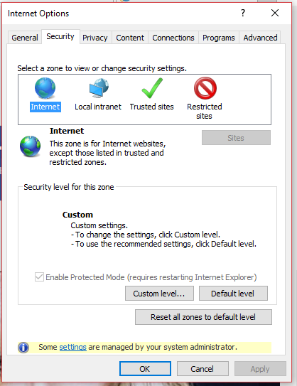

Click on Local intranet and click the chicklet to enable the protected mode

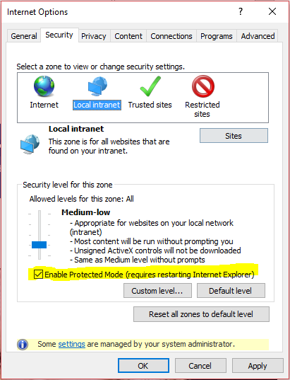

Click on Trusted sites and click the chicklet to enable the protected mode and then click Apply and Ok.

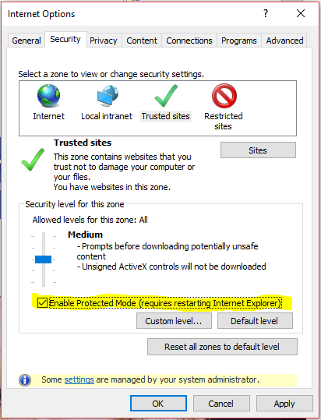

## Appendix

| Document Name | Key Points | Attachment |
| --- | --- | --- |
| Application Installation Manual | * Document describes the steps that need to be followed at the time of installation. |  |
| VFQA_TestDesign Manual | * Document describes the List of use case types with annotation templates * Usage types which has template, tool will auto populate. |  |
| User Execution Manual | * Document describes the steps to run the framework. |  |
| Mobile Usage Setup | * Document describes the installation setup for Mobile usage Scenarios. |  |